Bollington St. John’s Church of England
Primary School
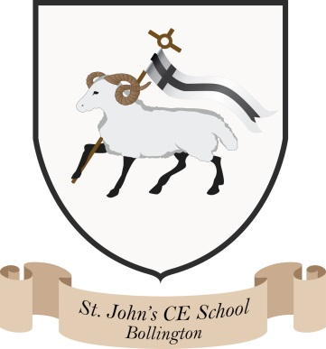
Where talent grows
Head Teacher: Mrs M. Walker
Head of Teaching, Learning and Assessment: Mrs E. Watson
“Whatever you do, work at it with all your heart, as working for the Lord”
Colossians 3:23
International Policy

At Bollington St John’s we are committed to promoting International Awareness throughout the school, the wider school community, local community and with our link partnerships. We aim to:

- Ensure pupils acquire a respect for their own culture and that of others and to understand core Global Values- and in turn- British Values
- Encourage pupils develop an interest in, curiosity about and respect for differences
- Ensure pupils develop the knowledge, skills and understanding, qualities and attitudes they need to understand, appreciate and contribute to culture
- Promote the importance of challenging stereotypes and becoming well-rounded global citizens.
- Encourage development of a sense of social justice

This is achieved by:

- Promoting the importance of global issues and international links
- Ensuring awareness of the Global Goals through assemblies, displays and P4C
- Inviting visitors from other countries into school
- Initiating communication links with other schools in the UK and abroad
- Reporting to governors as appropriate
- Informing the local media of international events taking place in the school
- Use of P4C to increase pupils’ awareness, confidence and engagement in global issues
- Global days being embedded into the school’s Long Term Plan
- A flexibility to allow pupils to take the lead in activities linked to global learning that they feel passionately about
- Pupils developing the knowledge, skills understanding, qualities and attitudes they need to understand, appreciate and contribute to culture

Date: November 2023

