Bollington St. John’s Church of England
Primary School
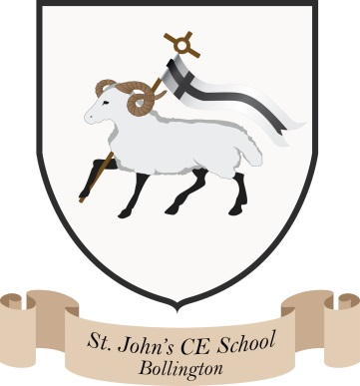
Where talent grows
Head Teacher: Mrs M. Walker
Head of Teaching, Learning and Assessment: Mrs E. Watson
“Whatever you do, work at it with all your heart, as working for the Lord”
Colossians 3:23
Christian Values
2023-2024
Autumn 1 | Respect
Autumn 2 | Compassion
Spring 1 | Trust
Spring 2 | Endurance
Summer 1 | Growth
Summer 2 | Peace

At Bollington St John’s we celebrate a new Christian Value each half term. We then explore this Value through our worship and Ethos group meetings, ensuring we link the theme to Bible stories.
Christian values are based on God, and the work of Jesus Christ. The most important Christian value is for a Christian to just value God more than anything, anybody, or any idea. Christian values are based on spiritual things, and the evidence of these values comes through deeds and actions.
Our Values are picked by the Ethos group and are proudly on display at the entrance to the school.

