Bollington St. John’s Church of England
Primary School
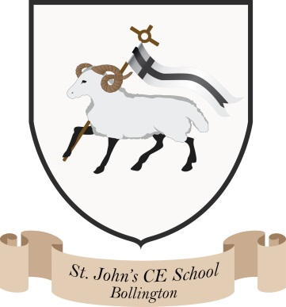
Where talent grows
Head Teacher: Mrs M. Walker
Head of Teaching, Learning and Assessment: Mrs E. Watson
“Whatever you do, work at it with all your heart, as working for the Lord”
Colossians 3:23

The Literacy Tree

What is The Literary Curriculum?

The use of high quality literature is important in schools; it expands its readers' horizons, opening minds to concepts and themes such as love, war and justice, as well as providing vital insights into historical settings with geographical and scientific knowledge woven within as part of the narrative. Developed by The Literacy Tree, who have all been school leaders, teachers and moderators, the Literary Curriculum immerses children in a literary world to provide meaningful and authentic contexts for writing. Children acquire an authorial style by engaging with significant authors and this has been developed into a cohesive whole-school approach, where sequences of work are provided that sit under themes which are mapped throughout the school.
The Literary Curriculum is a complete, thematic approach to the teaching of primary English that places children’s literature at its core.
Children explore over ninety literary texts and experience at least seventy-five unique significant authors as they move through the school.
As a whole-school approach, it provides complete coverage of all National Curriculum expectations for writing composition, grammar, punctuation and vocabulary, as well as coverage of spelling, phonics and reading comprehension. All plans lead to purposeful application within a wide variety of written outcomes. These high quality texts have formed the basis of our class reading spines. Each class has a bank of quality texts linked to literacy outcomes and cross curricular IPC topics alongside carefully chosen whole class novels suitable for each age group.

What makes this approach unique?

All plans include engaging starting points to generate interest, engage and activate inference. These link to the books’ themes and employ elements of dramatic conventions, which are maintained and addressed across the sequence.
Plans include explicit grammar objectives so that the grammar skills for writing are seen in context and can be applied within writing. These can be taught ‘discretely’ yet creatively, and still embedded firmly within the context of the book.
In addition, planning integrates spelling investigations and activities, so that patterns and rules can be explored, discovered and then used purposefully within writing.
Built into the plans are a variety of shorter and longer writing opportunities that are purposeful and pertinent to particular points of text. Children are encouraged to write in role, with bias and for a distinct audience, rather than writing in one fixed genre for the whole planning sequence.
Collectively the sequences help children build a literary repertoire; develop a knowledge of significant authors and prepares them for the subject content of critical reading at Key stage 3.

