Bollington St. John’s Church of England
Primary School
Where talent grows
Head Teacher: Mrs M. Walker
Head of Teaching, Learning and Assessment: Mrs E. Watson
“Whatever you do, work at it with all your heart, as working for the Lord”
Colossians 3:23

Bollington St John’s Anti-Bullying Policy: Respecting All

This policy has been developed and implemented in consultation with the school community, including pupils (the School Council, Global Ambassadors and No Outsiders Ambassadors), staff and governors. It was written with reference to the Equality Act 2010.
Bollington St John’s C of E Primary School promotes values which reject bullying behaviour and promote co-operative behaviour. Tackling bullying matters.
This should be read alongside our policies on Special Educational Needs, Behaviour and Child Protection and Safeguarding.

Statement of Intent
‘We are a global school, and we want to celebrate and value everyone in our school community. No one should be discriminated against, and everyone should be happy and valued for their wonderful unique qualities.’
School Council and No Outsiders Ambassadors

Bollington St John’s C of E Primary School is committed to providing a supportive, caring and safe environment in which all children are free from the fear of being bullied. We are a global school and a No Outsiders school, and we celebrate diversity, meaning that we want to value every individual in our community.
As a school, we take bullying and its impact seriously. Bullying of any form is not tolerated in our school, whether carried out by a child or an adult. If bullying does occur, all members of our community should be able to tell and know that incidents will be dealt with promptly and effectively.
Staff, children and parents or carers will be made aware of the school’s position on bullying. Bullying behaviour is unacceptable in any form. The school has high expectations of

outstanding behaviour and we consistently challenge any behaviour that falls below this.
We are a TELLING school. Anyone who knows that bullying is happening is expected to tell a member of staff.
Any child who is a victim of bullying will be dealt with in a sympathetic manner. If bullying is suspected or reported, the incident will be dealt with immediately by the member of staff informed, and then discussed with the Headteacher. A clear account of the incident will be recorded on CPOMS. All staff will be informed so that close monitoring of the victim and bully can begin. Parents of both parties will be informed.

What is bullying?
We recognise that many children and young people will experience conflict in their relationships with other children and young people, and as a school we are committed to developing empathy and the skills to manage relationships in a peaceful way that does not harm others.
In Bollington St John’s C of E Primary School, our definition of bullying is:
“The repetitive, intentional hurting of one person or group by another person or group, where the relationship involves an imbalance of power. It can happen face to face or online.”
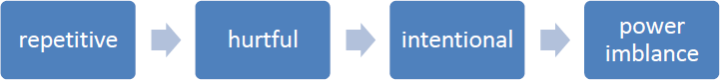

Why is it important to respond to bullying?
There is considerable evidence to show that bullying has both a short term and longer term impact on pupils. Bullying impacts on pupils’ wellbeing, can impact on attendance and become a significant barrier to learning. Bullying is associated with lower levels of school engagement and achievement both in primary and secondary schools and can lead to mental health concerns such as anxiety and depression.

Bullying is unacceptable. Our school will respond promptly and effectively to reported incidents of bullying.
In our school community:
- Everybody has the right to be treated with respect
- Everybody has the right to feel happy and safe
- No-one deserves to be a target of bullying
- Pupils who bully need to learn different ways of behaviour

National research has shown that some groups of pupils are particularly vulnerable to bullying, these include pupils with SEND, looked after children, pupils from minority ethnic groups or faiths, young carers, LGBT pupils and those perceived to be LGBT.

Types of bullying behaviour
Bullying can take many forms, including child on child abuse:
- Emotional - being unfriendly, excluding, tormenting, threatening behaviour
- Verbal - name calling, sarcasm, spreading rumours, teasing, use of derogatory language
- Physical - pushing, kicking, hitting, punching or any use of violence
- Extortion - demanding money/goods with threats
- Online - use of social media, messaging and calls. Misuse of associated technology, e.g. photos and videos
- Racist - racial taunts, graffiti, gestures
- Sexual - unwanted physical contact, sexually abusive comments
- Homophobic or biphobic - bullying because of sexuality or perceived sexuality
- Transphobic - because of gender identity or perceived gender identity

Preventing bullying
We foster a clear understanding that bullying, in any form, is unacceptable. We believe that preventing bullying is the responsibility of our whole school community and when there are incidents of bullying we will work together to deal with the situation and to learn from what has happened.
In our school, we do this by:
- Involving the school community in developing our policy, including pupils
- Using assemblies and circle time in class to ensure that pupils understand the differences between relational conflict and bullying
- Building a positive ethos based on respecting and celebrating all types of difference in our school
- Creating a safe and happy environment, consequently with positive relationships that have an impact on learning and achievement
- Having a positive ethos that all pupils, staff and parents understand
- Work which develops empathy, social skills and emotional understanding e.g. PSHE, Citizenship, social and emotional learning programmes, circle time, peer mediation and playground buddies
- Celebrating diversity and having pupil No Outsiders Ambassadors (No Outsiders is a wellbeing scheme of learning which promotes celebration of diversity and prepares young people for life as global citizens)
- Securing the safety of the target of bullying. Take actions to stop the bullying from happening again. Whole school learning / reflection on what we have learnt
- Thinking about any safeguarding concerns and reporting concerns to the Designated Safeguarding Lead
- Providing assurances to the child that concerns have been listened to and action will be taken
- Considering who else is involved and what roles they have taken
- Sending clear message that the bullying must stop
- Working with both parties to find solutions. Identify the most effective way of preventing reoccurrence and any consequences
- Reflecting and learning from bullying episodes / consider what needs to happen next to prevent future bullying, e.g. PSHE, training etc.

- Raising awareness of online bullying through regular e-safety lessons
- Adopting a social model approach to bullying. Diversity is valued and everyone is included in our school
- Focused work with individuals and groups of pupils where required to support understanding and development of social skills, e.g. social skills groups
- Ensuring playground and midday staff are trained and we have a range of activities at lunchtime to promote positive play
- Offering training to all school staff around bullying, including specific guidance on those groups who are most likely to be bullied

Reporting bullying
In our school, pupils are encouraged to talk to staff when they are unhappy or have concerns. Pupils in our school understand that they have a right to feel and be safe and a responsibility to support others to feel and be safe.
Pupils are encouraged to report bullying to:
- A trusted adult
- Their class teacher/TA
- Buddies or School Council/ No Outsiders group members

The school has a ‘worry box’ where children can report their concerns if they do not feel confident speaking to an adult.
Children are taught that it is important to talk to a trusted adult if bullying is taking place outside of school.
Parents are also encouraged to report concerns and bullying to named individuals. This is normally the class teacher.
When pupils report their concerns, our staff is trained to LISTEN and to BELIEVE. We involve children as far as possible in finding solutions.

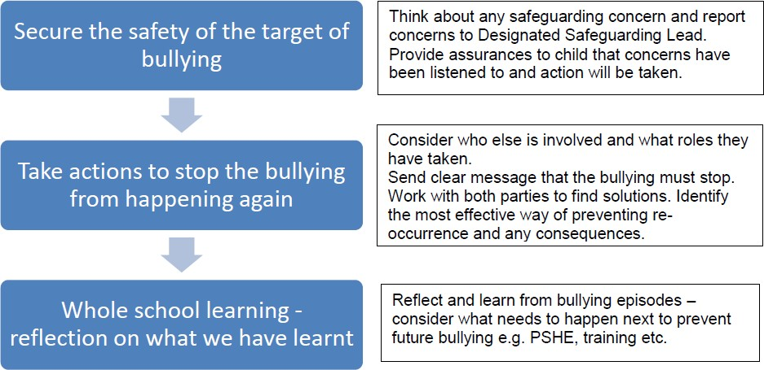
Responding to Bullying

We monitor and review all bullying incidents to determine any patterns or trends that may require further action.
On a regular basis, we give pupils the opportunity to feedback on how safe and happy they feel at school. We do this through pupil questionnaires and School Council meetings.
All staff are required to complete a CPOMS entry when dealing with incidents of bullying. This should be completed as soon as possible and signposted to the Designated Safeguarding Lead.

Procedures for parents:
If a parent has any concerns about their child, they should speak to the class teacher immediately. If a parent thinks bullying is the issue, the matter will be referred to the Headteacher. The Headteacher is always informed of any bullying concerns at Bollington St John’s C of E Primary and monitors the situation carefully.
- If a parent feels unable to talk to the class teacher, they can make an appointment to speak directly with the Headteacher
- The school will work with both the child and the parents to ensure that any bullying is stopped and that support is given where needed
- Parents should not confront the bully or their parents. This can complicate the situation and distress the pupil
- The school will deal directly with all children involved and their parents directly. Parents will be kept informed of any actions the school is taking

All members of the school community, including pupils, staff, parents and governors, are expected to treat everyone with dignity and respect at all times. This includes both face-to-face contact and online.

Date: November 2023

