Bollington St. John’s Church of England
Primary School
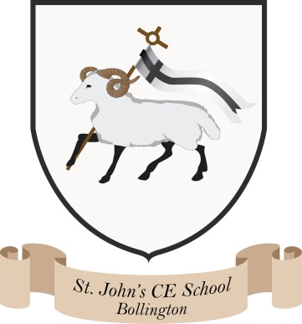
Where talent grows
Head Teacher: Mrs M. Walker
Head of Teaching, Learning and Assessment: Mrs E. Watson
“Whatever you do, work at it with all your heart, as working for the Lord”
Colossians 3:23
Collective Worship Policy
The aim of the collective worship policy is to provide the opportunity for pupils to:
- worship God
- reflect on Christian values and on their own beliefs
- gain better knowledge of the Bible and of the Christian calendar
- develop a community spirit, a common ethos and shared values
- consider spiritual and moral issues
- respond to the worship offered

Statutory Duty of School
All schools provide daily collective worship for registered pupils (apart from those who have been withdrawn by their parents). This is usually provided within a daily assembly.
The head teacher is responsible (under the School Standards and framework Act 1998) for arranging the daily collective worship after consulting with the governing body. Daily collective worship must be wholly or mainly of a broadly Christian character. The precise nature will depend on the family background, ages and abilities of the pupils.
- Bollington St John’s is a Voluntary Aided Church of England Primary School and, as such, our daily acts of collective worship are based on broad Anglican foundations, whilst respecting the personal integrity of all who attend.
- Our daily act of worship is fundamental to the ethos and atmosphere of our school.

Implementation
Collective worship, whether in assembly or classroom time, will:-
- be acceptable to the whole community, staff and pupils
- include a variety of elements at different times
- involve the pupils

Collective worship records are kept in a worship file in the hall, alongside planning linked to the current Christian Value, and evaluations made by staff members, children and members of the Ethos group. The school ethos group regularly meet to evaluate collective worship. Parents can view these records on request.
Acts of worship can be led by the Headteacher, teaching staff, the Vicar of St Oswald’s, support staff, governors and visiting speakers. The Headteacher / RE co-ordinator is responsible for the organisation and monitoring of collective worship. Collective worship can be monitored by staff, pupils, governors or parents.
Worship should make links with the spiritual, moral, social and cultural development of the pupils. Worship links to the current Christian Value and changes each half term.
Monitoring takes place through the SIAMS evaluation team and Committee 4 of the governing body
Resources are available in the RE resources areas in the head teachers office on each site. Useful websites for collective worship ideas are: www.cist.org.uk www.chester.anglican.org/schools www.christianvalues4schools.co.uk www.barnabasinschools.org.uk www.damaris.org www.ethoseducation.org
Pupils are involved in worship through reflection, praying (out loud and silently), singing, answering questions, responding, drama, monitoring and leading.
Monitoring, Evaluation and Review
The school will review this policy annually and assess its implementation and effectiveness. The policy will be promoted and implemented throughout the school.

Date: June 2025

