Bollington St. John’s Church of England
Primary School
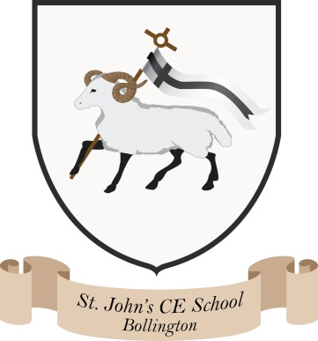
Where talent grows
Head Teacher: Mrs M. Walker
Head of Teaching, Learning and Assessment: Mrs E. Watson
“Whatever you do, work at it with all your heart, as working for the Lord”
Colossians 3:23

REPORTING ACHIEVEMENT POLICY

At St John’s we work in partnership with parents/carers. There are two parents evenings (pupil progress meetings) a year. These are in the autumn and spring terms. A full report is sent to parents/carers in the summer term.

We have introduced weekly class updates in our newsletter which is sent home via home contact each Friday. There is always a copy on the learning platform and we can send it home as a hard copy if you wish.

Assemblies can also provide updates on the children’s learning.

Pupil Progress Meetings

In the Foundation stage - progress towards the Early Years Foundation Profile is reported.

For Years 1 – 6 we will share with you our expectations. We report on your children’s targets for reading, writing and maths, the approximate level they are working at, and the next steps to achieve the level we are aiming for. We will also tell you how they relate to their peer group and also progress in all other areas of the curriculum.

Attendance percentage figures will also be reported to you with your full report.

Date: June 2025

