PE Funding

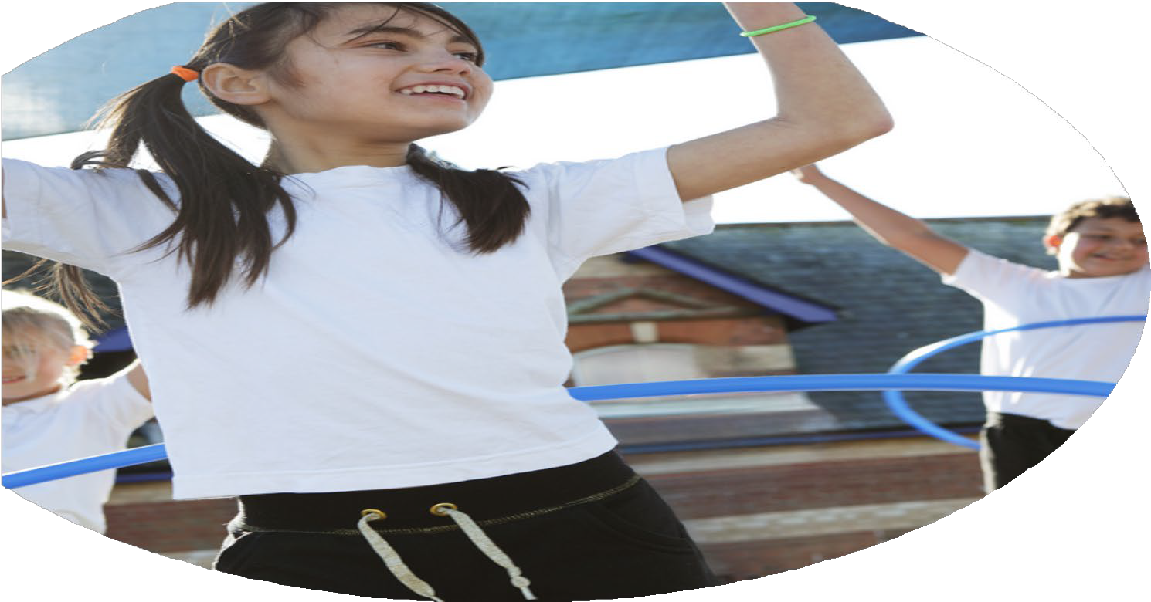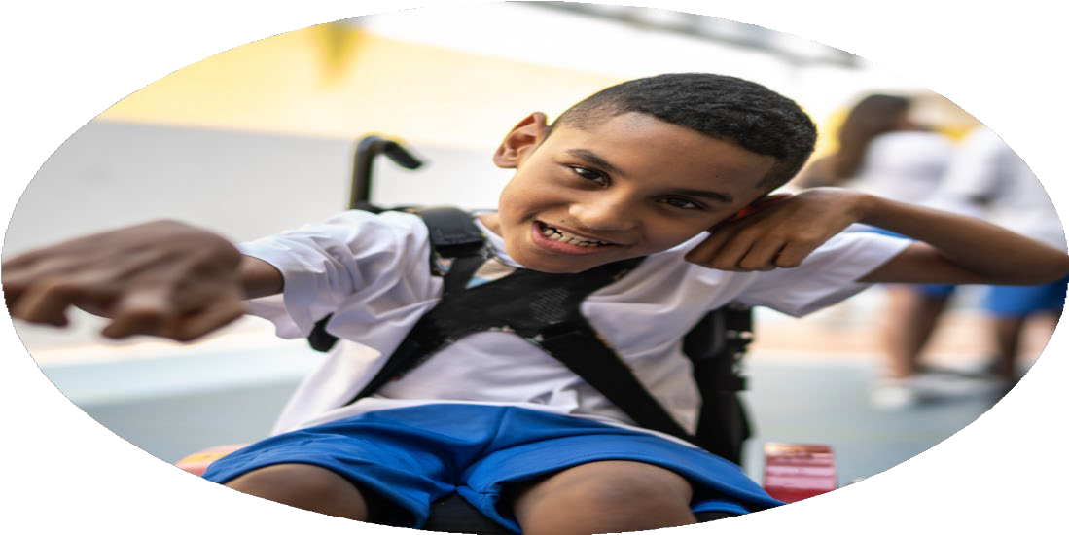

Evaluation Form

**Commissioned by**

**Created by**

Images courtesy of Youth Sport Trust

**PE Funding Evaluation Form**

 It is intended that this template should be used as preparation for the completion of the statutory digital reporting tool being introduced this academic year. You can upload data (including swimming) from this template onto this platform once it becomes accessible.

 Before you decide how you are going to use the funding for this academic year you should reflect and evaluate the impact of your use of the funding in 2023/24.

 All spending of the funding must conform with the terms outlined in the Conditions of Grant document.  The template is a working document that you can amend/update during the year.

 Based on your evaluation of last year’s funding you should decide what you intend to do this academic year, how you will do it, and what impact you expect it to have.

It is important that the funding is used effectively and based on your school’s needs.

 You must use the funding to make additional and sustainable improvements to the PE and sport in your school.  You must develop and add to the PESSPA activities that your school already offers.

*Summative digital reporting from June 2025 will continue to include swimming and water safety information therefore funding can be used to provide top-up lessons where necessary to ensure pupils meet national curriculum swimming requirements.*

**We recommend that you start by reflecting on the impact of current provision and reviewing your previous spend**

|  |  |  |  |
| --- | --- | --- | --- |
| What went well? | How do you know? | What didn’t go well? | How do you know? |
| Funding allowed St John’s to employ a PE Lead to teach PE, as well as to organise and implement extra-curricular clubs and competitive sporting events.    Funding has allowed children at St John’s to be transported to and from sporting events. Weekly swimming sessions take place across the school and funding allows St John’s to take part in such activities.  Funding has allowed St John’s to maintain and upgrade a high standard of equipment and resources which are used in a variety of settings. | Children are regularly involved in extra-curricular clubs and events, which demonstrates the progression of the school’s sporting opportunities.  Funding has allowed us to provide sporting opportunities to all children at St John’s. SEN, Pupil Premium and lower-ability children are encouraged and included in participation, as well as children who are more sport orientated.  Children’s mental health and attitudes towards school have developed and improved due to the sporting opportunities that St John’s provides. | Transportation and staffing are occasionally limited due to external factors and this can have an impact on opportunities and participation. | Evidence of effective use of funding is apparent because of attendance at clubs, positive impact of sporting opportunities seen in children and the provision provided by the PE Lead.  All children are regularly involved and included in many sporting activities and opportunities that have positively impacted their skills, sporting and social, as well as their wider school experience.  The significant increase in our girls’ participation, especially in football. |

|  |  |
| --- | --- |
| What are your plans for 2025/26? | How are you going to action and achieve these plans? |
| Intent | Implementation |
| * To use PE provision to provide school with a full time PE Lead. * To provide the children of St John’s with ample opportunity to take part in sport through; consistent quality first teaching in PE lessons that provides children with opportunities to develop skills, competitive sports fixtures and events in a range of sports and extra-curricular clubs that focus on developing children’s sporting skills and abilities. * To ensure all children at St John’s are included in weekly PE learning that engages them through a range of sports, skill-based sessions, fitness sessions and enjoyable sporting experiences. * To maintain an organised and effective physical education programme that ensures children are actively engaged in PE and to continue to provide multiple sporting opportunities throughout the year. * To include staff in the implementation of effective PE lessons and to engage staff in the development of their PE understanding and implementation. | * Employment of full time PE Lead who engages in planning, preparing and assessing PE throughout the school, providing quality CPD and training for all staff. * Continuous preparation of PE lessons for all classes. * Ongoing assessment of children’s progress. * Using a wide range of activities to ensure children develop their fundamental skills and gross motor skills. * Communicating with staff and schools in the region to ensure children are engaged in extra-curricular sporting activities. * Offering a wide range of sports clubs that take place daily. * Engage staff in PE learning objectives and provide staff with opportunities to develop their knowledge and understanding of PE. * School has ample sporting equipment to maintain effective PE lessons. |

|  |  |
| --- | --- |
| What impact/intended impact/sustainability are you  expecting? | How will you know? What **evidence** do you have or  expect to have? |
| * Children have an enhanced love for physical exercise and sporting activity. * Children are willing and enthusiastic to take part in extra-curricular physical activity and sport. * Children are engaged in and passionate about their development and performance. * Children are involved in and passionate about sporting opportunities. * Staff are able to and willing to assist in providing children with the opportunity to take part in PE and sporting activities. * Maintaining a PE programme that is based on a love for sport and physical education, creating a positive learning environment and ensuring children are engaged in PE and sport. | * A range of sporting opportunities that are well attended in school. * A range of sporting fixtures and events that are organised and attended. * Increased ability in children across their school life that has enabled them to progress their skills and competence in PE and sport. * Increased number of children that attend extra-curricular sporting activities, events and clubs. * Positive feedback from children, parents and staff about the opportunities provided. * Successful participation from children in sporting events and fixtures, as well as PE lessons. |

|  |  |
| --- | --- |
| What **impact/sustainability** have you seen? | What **evidence** do you have? |
| Impact  Funding has allowed St John’s to employ a full time PE Lead who engages all children in Physical Education and sports, as well as providing continuous daily extra-curricular clubs and activities. This has impacted children positively because many have been integrated into sporting activities and events which has allowed them to grow and develop their skills.  Teaching staff have been provided with high quality CPD.  Due to this, children at St John’s have become more motivated to participate in sport and the impact across the school has been monitored by the PE Lead.  Children have been continuously enrolled in swimming lessons, ‘bikeability’ and other sporting activities which have improved their knowledge and skills.  Outside providers come into school to teach and engage children in a variety of sports which has improved awareness and enthusiasm. | Extra-curricular sports clubs are well attended by at least fifteen children per day. A range of children attend different clubs due to the wide range of opportunities we offer. Regular attendance at extra- curricular after school clubs is well above 30% across the whole school and 50% of children have attended sports clubs this year.  Every year group, excluding Year 2, attends weekly swimming lessons for a full term. This is free of charge for families and has a hugely positive impact on children’s skills outside of the classroom.  Children are regularly involved in sports events and fixtures, particularly in the early autumn term, late spring term and summer term. |