Read Write Inc Overview

What is Read Write Inc? | Read Write Inc (RWI) is a complete phonics programme which helps all children learn to read fluently and at speed so they can focus on developing their skills in comprehension, vocabulary and spelling.  The programme is designed for children aged 4-7. However, at BSJ we begin the programme in Reception and will continue teaching RWI to children beyond the age of 7, as we use a stage not age approach.  RWI was developed by Ruth Miskin and more information on this can be found at https://ruthmiskin.com/en/find-out-more/parents/
How will RWI be taught? | All children are assessed regularly by our RWI lead teacher. From these assessments children are grouped into stages, where they work with peers on the same stage.
Reading
The children:
- Learn 44 sounds and the corresponding letters/letter groups using simple picture prompts – see below
- Learn to read words using Fred talk and sound blending
- Read from a range of storybooks and non-fictions books matched to their phonic knowledge
- Work well with partners
- Develop comprehension skills in stories by answering 'Find It' and 'Prove It' discussion questions

Writing
The children:
- Learn to write and form the letters/letter groups which represent the 44 sounds with the help of fun phrases
- Learn to write words by using Fred Talk
- Learn to build sentences by practising sentences out loud before they write

Talking
The children work in pairs so that they:
- Answer every question
- Practise every activity with their partner
- Take turns in talking and reading to each other
- Develop ambitious vocabulary

Progressing through the stages.
Children follow the same format as Early Years but will work on complex sounds and read books appropriate to their reading level. Daily sessions of RWI phonics last 45 minutes.

Five key principles underpin the teaching in all Read Write Inc. sessions:

Purpose: know the purpose of every activity and share it with the children, so they know the one thing they should be thinking about.
Participation: ensure every child participates throughout the lesson. Partnership work is fundamental to learning.
Praise: ensure children are praised for effort and learning, not ability.
Pace: teach at an effective pace and devote every moment to teaching and learning.
Passion: be passionate about teaching so children can be engaged emotionally.

Children will be taught how to read as follows: Before you start to teach your child, practice saying the sounds below. These are the sounds we use to speak in English. Children initially begin using pictures for each sound, this will help children recognise the sound and then form the shape of the sound.

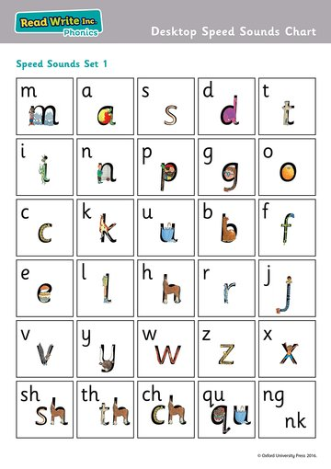
Fred Talk

We use pure sounds (‘m’ not’ muh’,’s’ not ‘suh’, etc.) so that your child will be able to blend the sounds into words more easily. At school we use a puppet called Fred who is an expert on sounding out words!
We call it, ‘Fred Talk’. E.g. m-o-p, c-a-t, m-a-n, sh-o-p, b-l-a-ck.
The following video is an example of blending sounds with Fred. https://www.youtube.com/watch?v=dEzfpod5w_Q

Step 1
Set 1 Sounds are taught in the following order together with rhymes to help children form the letters correctly and instantly recognise sounds ready for blending.
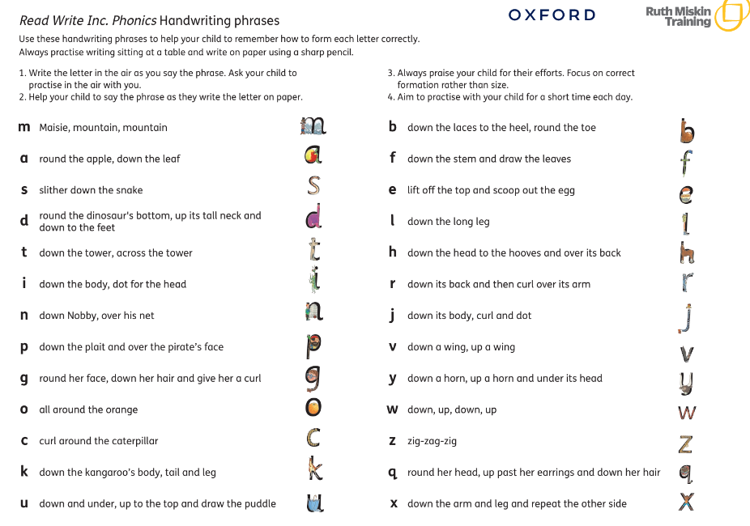

At this stage we do not use the letter names.

Use the link below to support your pronunciation sounds correctly.
https://www.ruthmiskin.com/en/find-out-more/parents/#lg=1&slide=3

Step 2
The children are then taught Set 2 Sounds- the long vowels.
When they are very confident with all of set 1 and 2 they are taught Set 3 Sounds.

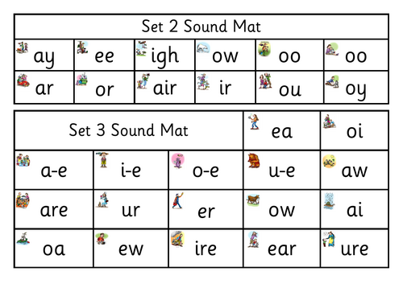
Nonsense words (Alien words)
What 'a load' or nonsense!

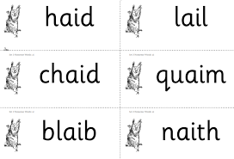

As well as learning to read and blend real words children will have plenty of opportunities to apply their sound recognition skills on reading ‘nonsense words’. These words will also feature heavily in the Year One Phonics Screening check in the summer term.
These words provide endless opportunities for children to apply and practice their thinking in a range of different contexts.

Step 3
Within all the RWI sessions/books children will be exposed to red and green words to learn to help them to become speedy readers.
Red words are words that are not easily decodable and challenge words to extend children’s vocabulary.
Green words are linked to the sounds they have been learning and are easily decodable.

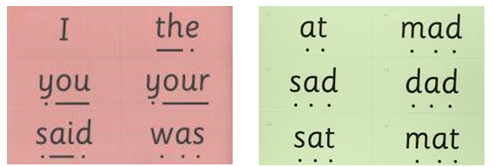

Dots and dashes represent the sound each letter makes.

During the RWI session children will read the book three times and at each new reading they will have plenty of opportunities to practise using their developing comprehension skills.

You may have heard your child talking about ‘hold, build or edit a sentence’.
Hold a sentence is an activity that encourages children to remember a whole sentence while focusing on spelling and punctuation.
Build a sentence is to give children the opportunity to create their own sentence that shows the meaning of a word and editing a sentence allows the children to critique a sentence using their knowledge of spelling, punctuation and grammar.

Children complete a longer piece of independent writing, which gives them the opportunity to show off their creativity and to practice their spelling, grammar and punctuation.

To help at home | Your child will start to bring books home when they are confident readers, relating to their reading stage.  You will find they will bring home a phonics based book, this will aid application, speed and fluency- developing speedy reading.  Following on from this, they will bring a comprehension based book which will begin to enrich their reading, which will require decoding skills.  Only then, children will bring home enriched reading books which will enhance their understanding via inspirational language promoting depth to their understanding.  Encouraging your child to read their RWI book several times a week is crucial to building fluency and a developing a love of reading.  Bedtime stories every night will extend their passion further, build a huge bank of vocabulary and develop comprehension.

