WHAT’S ON AT ST OSWALD’S THIS CHRISTMAS

Dear Parents/Carers,
Christmas is always a very special time of year and possibly even more so this year as we missed out on so much in 2020. All of us at St Oswald’s Church would like to extend a very warm welcome to you and your family for any of our Christmas services. Here’s what we have going on this Advent and Christmas season:
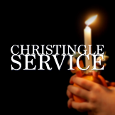
Sunday 5th December @ 4pm
Come and join us for this service celebrating the work of the Children’s Society and hear about the origins of how this popular tradition began.

Sunday 12th December @ 3.00pm - Carol Service with Bollington Festival Choir
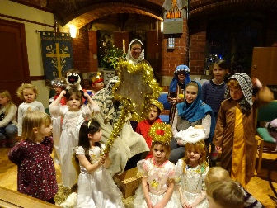
Christmas Eve - 4pm – Interactive Family Nativity Service –Experience the excitement of the very first Christmas here at St Oswald’s as if you were a visitor to Bethlehem. Feast at the Inn, follow the shepherds to the stable and wonder at the Baby Jesus. Wear your own costume or borrow one of ours. A lovely way to begin your Christmas celebrations.
Christmas Eve – 11.15pm – First Communion of Christmas [Midnight Mass]
Christmas Day - 10.30am - Family Communion
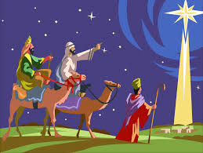
Sunday 2nd January 2022 @ 10.30am
Family Worship for Epiphany – Join us to hear the story of the 3 Wise Men who followed an amazing star to find a very special baby.

Regular activities at St Oswald’s:
Praise and Play. Our parent toddler group is held here in St Oswald’s on Tuesdays between 9.30 and 11 am. Come and join us for a time of stories, songs, and crafts. Refreshments included.
Family Worship is held at 10.30am on the first Sunday of every month. This is an informal, relaxed service especially for young families, worshipping God through story, song, and prayer.
Family Communion is held on the third Sunday of the month at 10.30am. Less formal than our normal Communion service, providing plenty of opportunities for children to participate in the proceedings.

Further information on all our activities can be found on our website at www.stoswaldbollington.org.uk
Or on our facebook page

