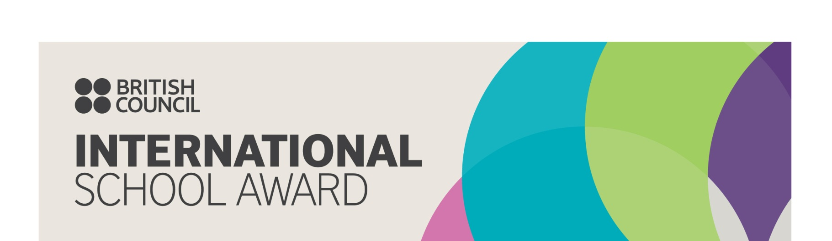
Press release 25th September 2020

British Council International School Award success for
Bollington, St John’s Primary School

Bollington St John’s Primary School has been awarded the British Council’s prestigious International School Award in recognition of its work to bring the world into the classroom.

The International School Award celebrates the achievements of schools that do exceptional work in international education. Fostering an international dimension in the curriculum is at the heart of the British Council’s work with schools, so that young people gain the cultural understanding and skills they need for life work in today’s world.

Bollington St John’s international work includes a whole school and community plastic pledge, where the children, parents and governors signed an agreement to reduce the use of plastics. This initiative was started by the school’s student council and global ambassador pupils. They also spoke to former Bollington Mayor, Roland Edwards, and local town councilors about the work they had done towards the United Nation’s Sustainable Development Goals.
The older pupils in the school also took place in a ‘Take Over Day’ where they took over the roles of staff member, writing job applications and having interviews beforehand. This allowed the children to explore the skills, qualities and characteristics needed in different careers.
The pupils also celebrated European Day of Language, alongside their partner school in Romania, learning about the importance and enjoyment of language learning.

On hearing the news that Bollington St Johns had received the award, Melanie Walker (Headteacher) said:
We are delighted that the school has received this award. At Bollington St Johns, we are passionate about ensuring the pupils recognise their place as global citizens. We want our pupils to be aware of global issues and know that they all can have a positive impact on our wonderful world.

Sir Ciarán Devane, CEO of the British Council, said: ‘The school’s fantastic international work has rightfully earned it this prestigious award. The International School Award is a great chance for schools to demonstrate the important work they’re doing to bring the world into their classrooms. Embedding an international dimension in children’s education ensures that they are truly global citizens and helps prepare them for successful lives and careers in an increasingly global economy.’

The award, which celebrates its 20th Anniversary this year, is now available worldwide in countries such as India, Sri Lanka, Egypt, Lebanon, Nigeria, and Pakistan. Over 6000 International School Awards have been presented to successful schools in the UK since the scheme began in 1999.

The International School Award encourages and supports schools to develop:
- An international ethos embedded throughout the school
- A whole school approach to international work
- Collaborative curriculum-based work with a number of partner schools
- Year-round international activity
- Involvement of the wider community

- ENDS -

For more information about the International School Award, please contact our team at schools@britishcouncil.org

Notes to Editors:

The British Council International School Award started in 1999 to recognise the schools leading the way in instilling and developing a global dimension into the learning experience of all children and young people. It is managed by the British Council and celebrates its 20th Anniversary in 2019.

The British Council is the UK’s international organisation for cultural relations and educational opportunities. We work with over 100 countries in the fields of arts and culture, English language, education and civil society. Last year we reached over 65 million people directly and 731 million people overall including online, broadcasts and publications. We make a positive contribution to the countries we work with – changing lives by creating opportunities, building connections and engendering trust. Founded in 1934 we are a UK charity governed by Royal Charter and a UK public body. We receive 15 per cent core funding grant from the UK government.

For more information, please visit: www.britishcouncil.org. You can also keep in touch with the British Council through http://twitter.com/britishcouncil and http://blog.britishcouncil.org/.

